Data Insights and Visualization Report

Did you ever get 14 out of 10? Well many dogs got that score from the very popular tweeter account WeRateDogs (@dog_rates), its unique scoring schema got them more 8.7 million followers.

In this article, I’ll show some interesting insights and charts that I found by analyzing more than 2000 of its tweets. First, by analyzing the dog stages I found that in average puppo, floofer, and doggo were getting higher rating of 12/10 approximately, while puppers where getting 11 in average. That rate goes along with followers’ opinions but with more extreme bias to puppos and doggos, as when I analyzed the number of retweets and favorites that each stage got, boor puppers got only +7K favorites, while puppos got +21K in average.

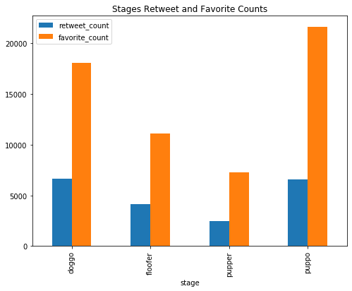

I found that interesting, so I started wondering if the accounting rating of each dog breed matches with their followers rating, hence I got the photos in the tweets classified by a neural network algorithm. After that calculated the average rating of each predicted breed, and filter to the top five breeds, to find that Bouvier des Flandres got the highest average rate of 1.3, followed by Saluki rated 1.25 in average. However, when I turned to analyze the followers’ favorites, it was clear that they have a different opinion this time as Saluki came first followed by Bedlington Terrier, which never appeared even in the list of 25 top rated breeds. Interesting, right?

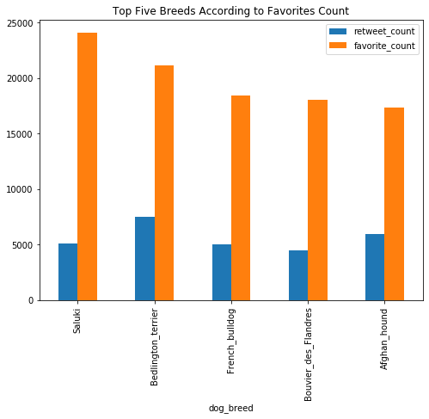

Eventually, if you are interested here I brought for you [the most favorited tweet](https://t.co/nTz3FtorBc) and [the most retweeted](https://t.co/7wE9LTEXC4) one, maybe it will be a good starting point for your tour in the account tweets.